22.25: 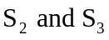 enclose no charge, so the flux is zero, and electric field outside the plates is zero. For between the plates, 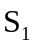 shows that: 